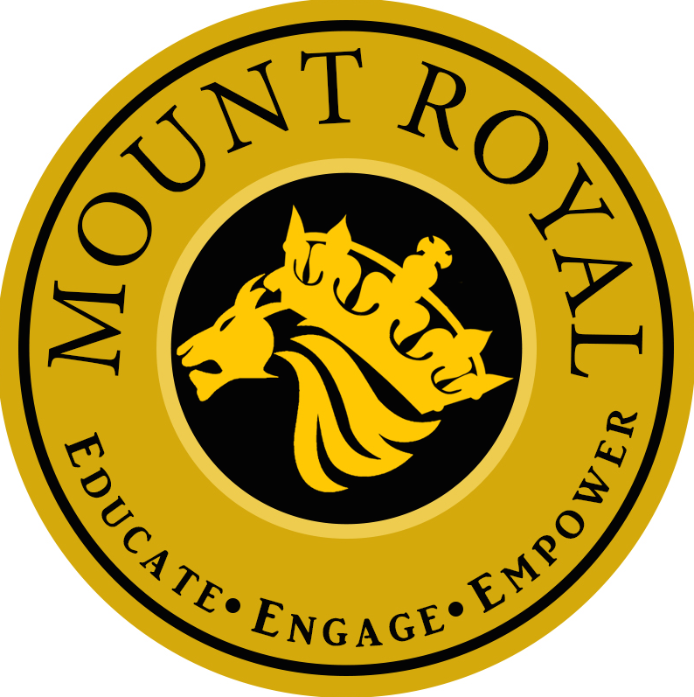 Grade 9
Mount Royal School
Course Outline 2017 -2018
Welcome to Grade 9!!

9A/B Math/Science- Ms. O’Keefe/ Ms. Booth kiokeefe@cbe.ab.ca
ldbooth@cbe.ab.ca LA/Social- Ms. Hamm majhamm@cbe.ab.ca

9C Math – Ms. Teasdale smteasdale@cbe.ab.ca
Science- Mr. Van Kleeck tivankleeck@cbe.ab.ca LA/Social Studies – Mr. Fettes dwfettes@cbe.ab.ca

Expectations

All students are expected to:

- Attend and be in class on time
- Come to class prepared with materials
- Show respect for self, others, and school community
- Complete homework and assignments
- Seek out extra help if needed
- Be responsible for all textbooks assigned to them
- Check teacher blog daily

Assignments and Homework

- All assignments are to be before the due date given unless prior arrangements were made with your teacher
- If absent, it is the student’s responsibility to make up missed assignments and/or notes
- Students are expected to prepared for upcoming tests and quizzes
- Teachers are available to support students with homework and assignments if extra clarification and understanding are needed

Math and Science Curriculum

The Math 9 program supports the belief that students learn in different ways and must construct their own meaning of mathematics. Students will be covering the 4 strands; Number Sense, Patterns and Relations, Shape and Space as well as Statistics and probability through a unit based program. The units that are covered in Grade 9 are Rational Numbers, Powers, Exponents and Square Roots, Similar Polygons, Measurement, Linear Relations, Equations, and Inequalities, Polynomials, Probability, Symmetry, Circle Geometry, Data Collection and Analysis.

Students will be evaluated based on the following stems using a 4 point scale:

Mathematics
- Understands mathematical concepts and relationships
- Uses mathematical reasoning to analyze and solve problems
- Explores and develops strategies for mental mathematics and estimation
- Develops mathematical procedures and strategies for computation
- Models, represents and communicates mathematical ideas

The Science 9 program is designed to deepen students’ understanding of the scientific concepts and processes needed to explore and understand our world. Throughout the year we will develop skills, make connections, and develop critical thinking and problem solving skills.

Students will be provided with opportunities to demonstrate mastery of the outcomes of the Grade 9 Program of Studies, and beyond, through a variety of scientific experiences. There are four foundations of science that students are exposed to within each of the units covered:

- Science, technology, and society
- Knowledge
- Skills
- Attitudes

The 5 units in Grade 9 Science are: Biological Diversity, Matter and Chemical Change, Electrical Principles, Environmental Chemistry and Space Exploration.

Students will be evaluated based on the following stems using a 4 point scale:

Science
- Understands and makes connections between concepts
- Analyzes and solves problems through scientific reasoning
- Develops skills for inquiry and communication
- Explores scientific events and issues in society and the environment

Social Studies
The grade nine unit of study focuses on issues within Canada. The issues covered include government, justice, collective rights, charter of rights, immigration, economics of Canada and the U.S.A., social programs, consumerism, and quality of life.

The unit of study includes two topics:
A: Issues for Canadians: Governance and Rights: Students will demonstrate an understanding and appreciation of how Canada’s political processes impact citizenship and identity in an attempt to meet the needs of all Canadians.
B: Issues for Canadians: Economic Systems in Canada and the U.S.: Students will demonstrate an understanding and appreciation of economic decision making in Canada and the United States impacts quality of life, citizenship and identity.

Current Event issues will also be discussed on a regular basis. It is recommended that students pay attention to local, national and international news.

Students will be evaluated based on the following stems:

Social Studies
- Demonstrates knowledge and understanding of citizenship and identity
- Explores events and issues from different points of view
- Demonstrates skills and processes for inquiry and research
- Communicates ideas in an informed and persuasive manner

English Language Arts
Communication skills will be covered within the framework of the above content topics or separately as necessary. Students will read, write, speak, listen, view and represent to: explore their world; respond to literature; manage ideas and information; communicate artfully and clearly; and respect, support and collaborate with others. In order to achieve these goals, a variety of literature and visuals will be used, including short stories, poetry, novels, film, and non-fiction articles. Projects include research assignments, writing assignments and presentations. Class work includes shorter writing assignments including grammar and sentence structure, and class and small group discussions.

Students will be evaluated based on the following stems:

English Language Arts
- Reads to explore, construct and extend understanding
- Writes to develop, organize and express information and ideas
- Manages and evaluates information and ideas
- Constructs meaning and makes connections through speaking
- Constructs meaning and makes connections through listening
- Represents ideas and creates understanding through a variety of media

At Mount Royal we believe that it is essential for students to respect themselves and others, the school environment, and our community. We expect these ideas to be in full force in our classrooms. We look forward to seeing you on Thursday September 21st at Meet the Teacher evening.

Parents, please review this sheet with your student. If you have any questions or concerns, please call the school at 777-7980.

